UNIT-2. PROMPT ENGINEERING AND AI-ASSISTED CONTENT CREATION

TUTORIAL TASK-1:ACADEMIC PROMPT LIBRARY

PROBLEM STATEMENT:Develop a categorized prompt library for learning, research, and academic productivity

Prompt

Role: You are an AI Learning and Research Assistant specializing in education, academic writing, research organization, and productivity.

Objective: Develop a categorized prompt library that helps students, researchers, and educators complete academic tasks efficiently.

Instructions: Create prompts under the following categories:

1.Learning & Study

- Explain difficult concepts in simple language.
- Create study notes from textbooks.
- Generate quizzes and flashcards.
- Design personalized study plans.

2.Research
- Generate research questions.
- Conduct literature review summaries.
- Compare research papers.
- Identify research gaps.
- Suggest future work.

3.Academic Writing

- Write essays and reports.
- Improve grammar and clarity.
- Generate introductions and conclusions.
- Create abstracts.

4.Presentation Preparation

- Create slide outlines.
- Generate speaker notes.
- Design presentation flow.

5.Productivity
- Create daily and weekly study schedules.
- Prioritize academic tasks.
- Track assignment deadlines.
- Recommend productivity techniques.

For each prompt, include:

- Purpose
- Prompt Template
- Expected Output
- Recommended AI Model
- Best Practices

Present everything in a well-organized table.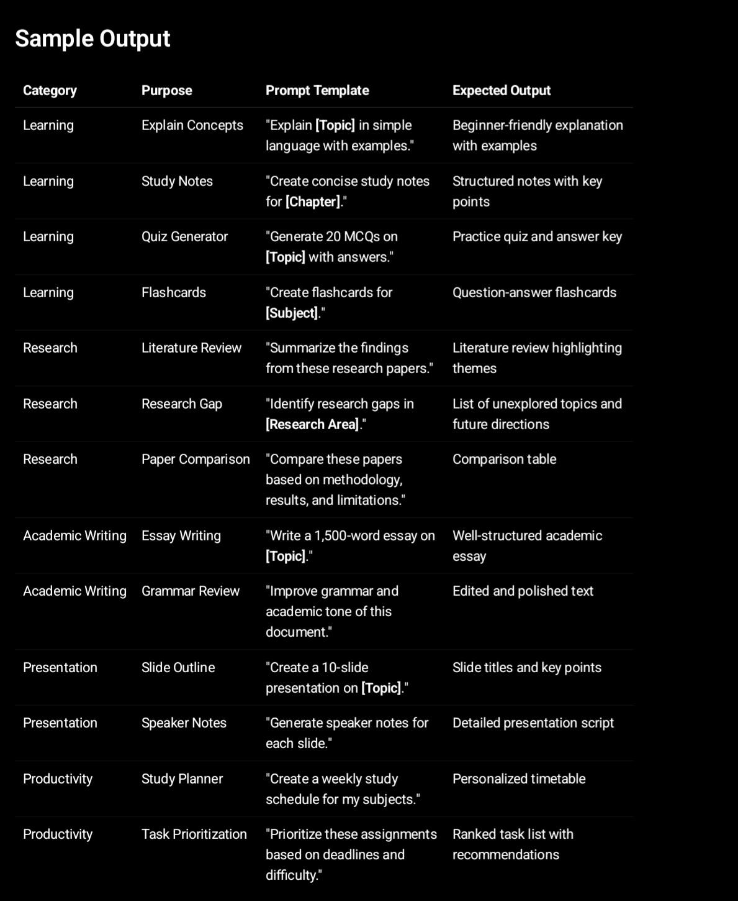

Output:
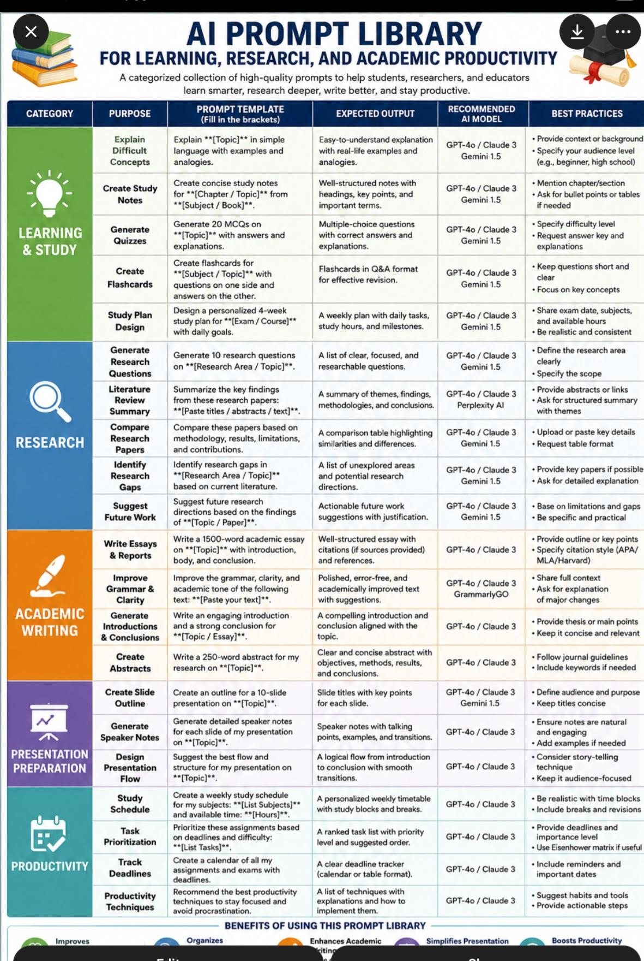
Tutorial task:2. Coding prompt collection

Problem Statement: Develop prompt templates for programming, debugging, and software development assistance.

Prompt
Role: You are an AI Software Development Assistant with expertise in programming, debugging, software architecture, testing, and code optimization.
Objective: Develop a categorized prompt library that helps developers, students, and software engineers write, debug, test, and document code efficiently.
Instructions: Create prompt templates under the following categories:
1.Code Generation
- Write code from requirements.
- Convert pseudocode into code.
- Generate reusable functions and classes.
- Create REST APIs and database models.

2.Debugging
- Identify errors in code.
- Explain compiler/runtime errors.
- Suggest bug fixes.
- Optimize inefficient code.
3.Code Review & Optimization
- Review code quality.
- Improve readability.
- Optimize performance.
- Apply best coding practices.
4.Testing
- Generate unit tests.
- Create integration test cases.
- Suggest edge cases.
- Improve test coverage.
5.Documentation
- Generate code comments.
- Create API documentation.
- Write README files.
- Explain algorithms and workflows.
6.Software Design
- Design software architecture.
- Recommend design patterns.
- Create UML diagrams (text description).
- Plan project structure.
7.For each prompt, provide:
- Purpose
- Prompt Template
- Expected Output
- Recommended AI Model
- Best Practices
- Present the information in a structured table.

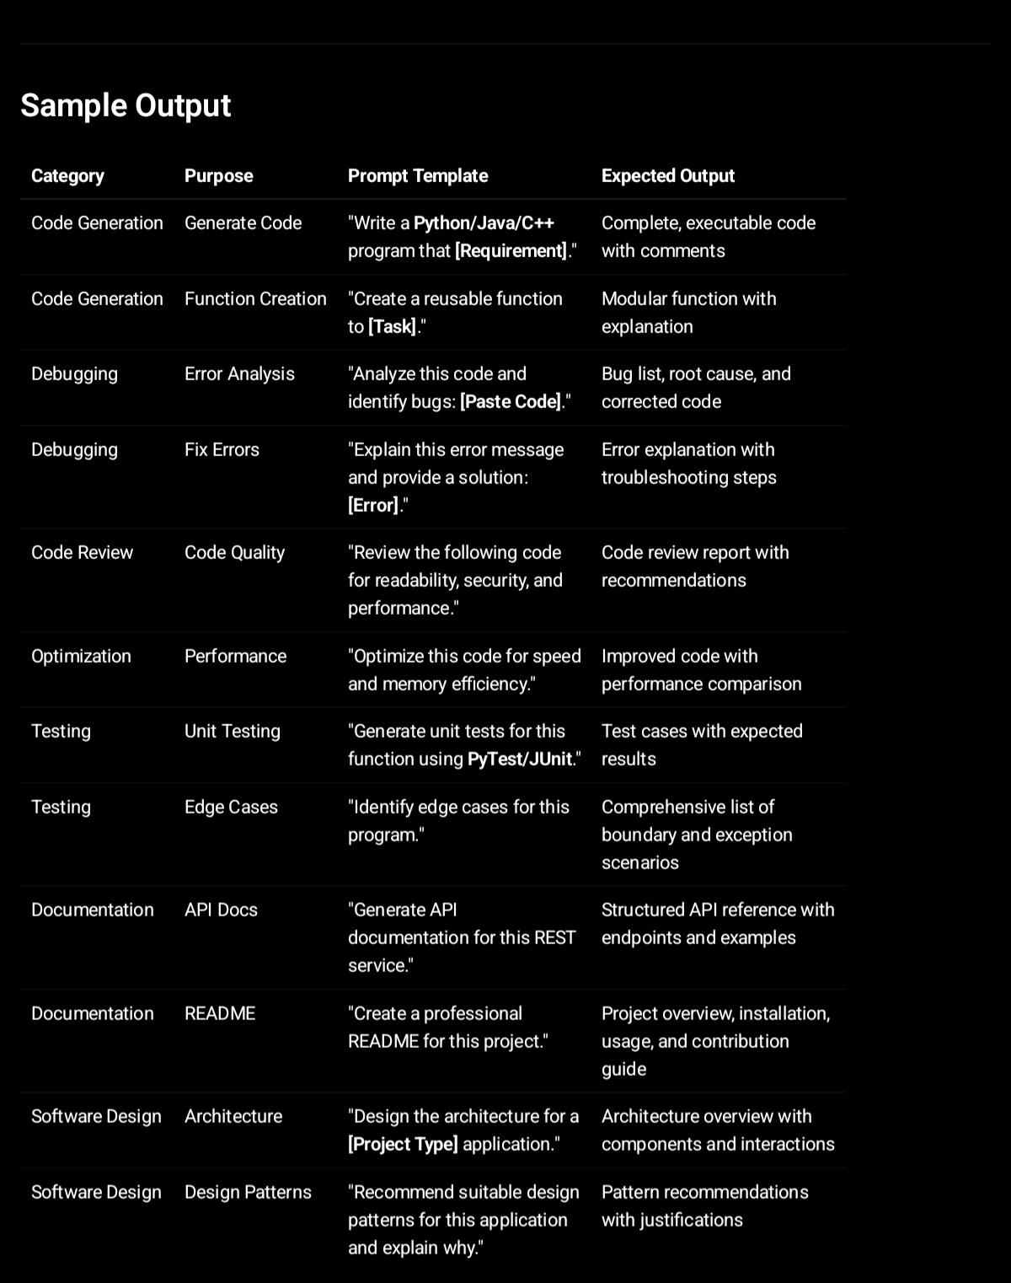
Output:

1. Code Generation Prompts
Prompt Template 1: Generate a Function

Act as a senior software engineer.

Generate a [PROGRAMMING_LANGUAGE] function that:
- Purpose: [FUNCTION_PURPOSE]
- Inputs: [INPUT_PARAMETERS]
- Output: [EXPECTED_OUTPUT]
- Constraints: [CONSTRAINTS]

Requirements:
- Follow best practices.
- Include error handling.
- Add comments explaining the logic.
- Provide example usage.
Example

Generate a Python function that:
- Calculates factorial of a number
- Input: Integer n
- Output: Factorial value
- Constraint: n >= 0

2. Debugging Prompts
Prompt Template 3: Error Analysis

Act as an expert debugger.

Analyze the following code and error message.

Code:
[PASTE_CODE]

Error:
[PASTE_ERROR]

Tasks:
1. Explain the root cause.
2. Identify the exact line causing the issue.
3. Provide a corrected version.
4. Suggest preventive measures.
Example

Code:
x = [1,2,3]
print(x[5])
03. AI Pair Programming Prompt
Prompt Template 18: Coding Assistant

Act as my pair programmer.

When solving problems:
1. Understand requirements.
2. Suggest architecture.
3. Explain trade-offs.
4. Generate production-ready code.
5. Write tests.
6. Review the solution.
7. Recommend improvements.

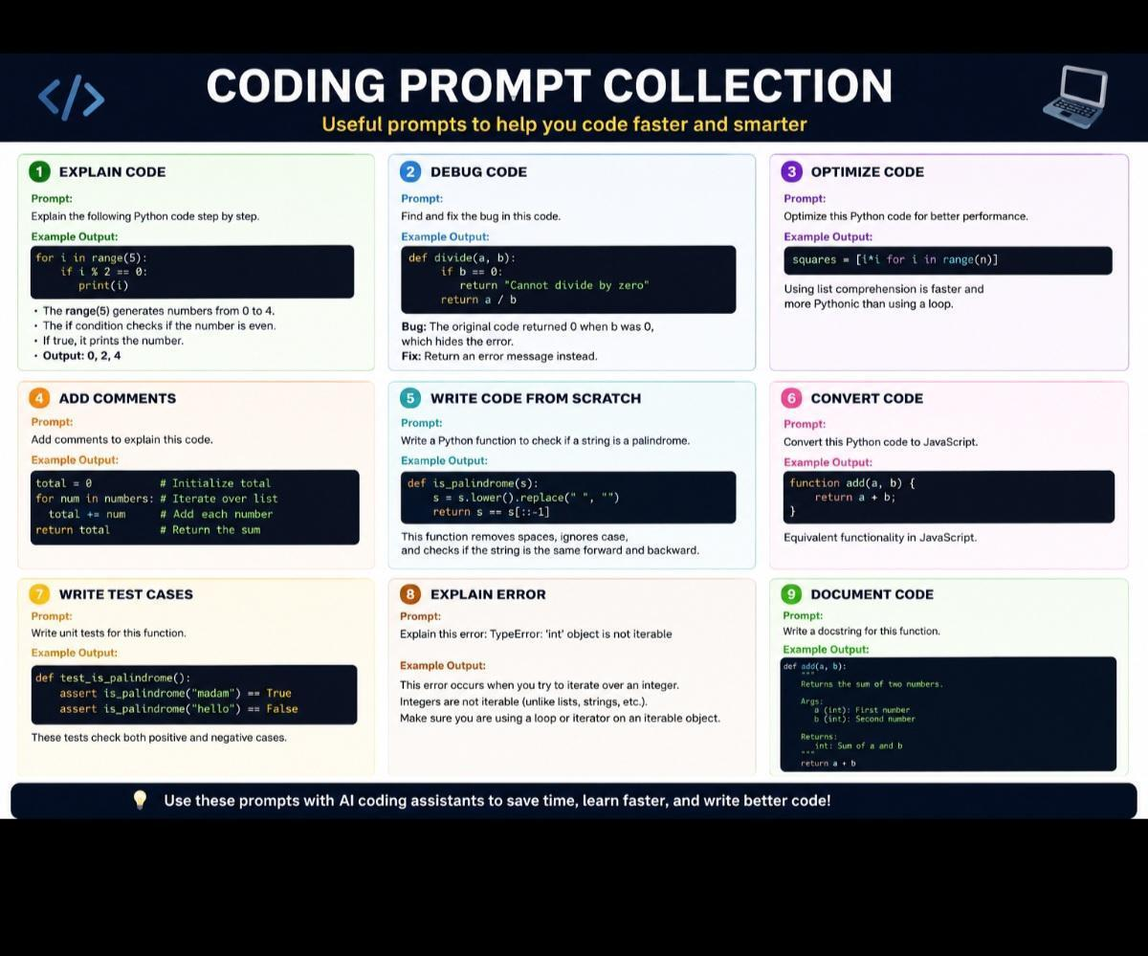

Tutorial Task 23: Resume Optimization System
Problem Statement: Use AI-assisted prompting to improve resumes for specific job roles.

Prompt

Role:

You are an AI Resume Optimization Specialist and Career Coach. Your task is to customize and improve a resume for a specific job role while ensuring it is ATS (Applicant Tracking System) friendly.

Input:

- Target Job Role: [Job Title]
- Industry: [Industry]
- Candidate Resume: [Paste Resume]
- Years of Experience: [X Years]
- Skills: [List Skills]
- Job Description: [Paste Job Description]
Instructions:

1.Analyze the job description and identify the most important skills, qualifications, and keywords.
2.Optimize the professional summary to match the target role.
3.Rewrite work experience using strong action verbs and measurable achievements.
4.Highlight relevant technical and soft skills.
5.Add missing ATS keywords naturally.
6.Suggest improvements to formatting and readability.
7.Recommend certifications or projects that would strengthen the application.
8.Provide an ATS compatibility score (out of 100).
9.List all changes made and explain why they improve the resume.
10.Generate the final optimized resume.

Sample Output

AI Resume Optimization Report
Target Role

Software Developer

ATS Compatibility Score

92/100

Keywords Added
- Java
- Python
- SQL
- REST APIs
- Git
- Agile
- Problem Solving
- Cloud Computing
- Data Structures
- Team Collaboration

Software Developer

ABC Technologies | 2023–Present
- Developed and maintained scalable web applications using Java and Spring Boot.
- Improved application performance by 30% through code optimization.
- Built and integrated REST APIs serving over 10,000 users.
- Collaborated with cross-functional Agile teams to deliver projects ahead of schedule.
- Reduced software defects by 25% through comprehensive testing and code reviews.
Skills
Programming Languages

- Java
- Python
- SQL

Frameworks & Tools

- Spring Boot
- Git
- Docker
- REST APIs
Cloud

- AWS

Soft Skills
- Communication
- Teamwork
- Problem Solving
- Time Management

Suggested Certifications

- AWS Certified Cloud Practitioner
- Oracle Certified Java Programmer
- Microsoft Azure Fundamentals

Recommended Projects

- Employee Management System
- Cloud-Based Task Management Application
- Online Banking System using Spring Boot
- AI-Powered Chatbot

AI-Assisted Resume Improvement – Sample Output
Resume Optimization Report
Candidate Profile
- Name: John Smith
- Target Role: Data Analyst
- Industry: Information Technology
- Experience: 3 Years
1. Resume Analysis
Strengths
- Bachelor's degree in Computer Science.
- Experience using SQL and Microsoft Excel.
- Strong analytical and problem-solving abilities.
- Experience working with business datasets.
Areas for Improvement
- Professional summary lacks impact.
- Missing important ATS keywords.
- Work experience needs measurable achievements.
- Technical skills section is incomplete.
- No projects or certifications listed.
- Resume formatting can be improved for ATS compatibility.
2. Missing ATS Keywords
Technical Skills Business Skills
Python Business Intelligence
Power BI KPI Reporting
Tableau Data Visualization
Machine Learning Decision Making
ETL Stakeholder Communication
Statistics Process Improvement

3. Optimized Professional Summary

Results-driven Data Analyst with 3 years of experience analyzing business data, developing dashboards, and generating actionable insights using SQL, Python, Excel, and Power BI. Proven ability to improve reporting efficiency, automate workflows, and support strategic business decisions through data-driven analysis.
4. Enhanced Work Experience
Data Analyst
ABC Technologies
Before
- Worked with Excel reports.
- Created SQL queries.
- Helped management with reports.
After AI Optimization
- Developed interactive Power BI dashboards, reducing reporting time by 40%.
- Automated weekly reports using Python, saving 15+ hours per week.
- Created optimized SQL queries, improving database performance by 30%.
- Analyzed customer behavior data that increased marketing campaign performance by 20%.
- Delivered KPI reports to senior management for strategic decision-making.
- Collaborated with cross-functional teams to improve operational efficiency.
5. Optimized Skills Section
Technical Skills
- Python
- SQL
- Microsoft Excel
- Power BI
- Tableau
- Data Visualization
- Machine Learning (Basic)
- Statistics
- ETL
- Business Intelligence
Soft Skills
- Communication
- Team Collaboration
- Problem Solving
- Critical Thinking
- Time Management
- Leadership
- Decision Making
6. Recommended Projects
Project Technologies Used
Sales Dashboard Power BI, SQL
Customer Churn Prediction Python
Retail Sales Analysis SQL, Excel
HR Analytics Dashboard Power BI
Financial Reporting Dashboard Excel, Power BI

7. Recommended Certifications
- Google Data Analytics Professional Certificate
- Microsoft Power BI Data Analyst Associate
- SQL for Data Science
- Python for Data Analysis
- Tableau Desktop Specialist
8. ATS Compatibility Score
Category Score

Keyword Optimization 96%
Formatting 98%
Skills Match 95%
Experience Quality 94%
Readability 97%
Overall ATS Score 96%

9. Final Resume Snapshot
John Smith
📧 john.smith@email.com | 📞 +91-9876543210 | 📍 Hyderabad, India
Professional Summary
Results-driven Data Analyst with 3 years of experience in SQL, Python, Excel, and Power BI. Skilled in transforming complex data into actionable insights, improving reporting efficiency, and supporting strategic business decisions.
Experience
Data Analyst – ABC Technologies
Reduced reporting time by 40% using Power BI dashboards.
Automated reporting processes, saving 15+ hours per week.
Improved database performance by 30% with optimized SQL queries.
Increased marketing effectiveness by 20% through customer analytics.
Education
Bachelor of Technology in Computer Science
Technical Skills
Python • SQL • Excel • Power BI • Tableau • ETL • Statistics • Data Visualization
Certifications
- Google Data Analytics Professional Certificate
- Microsoft Power BI Data Analyst Associate
Projects
- Sales Dashboard
- Customer Churn Prediction
- Retail Sales Analysis
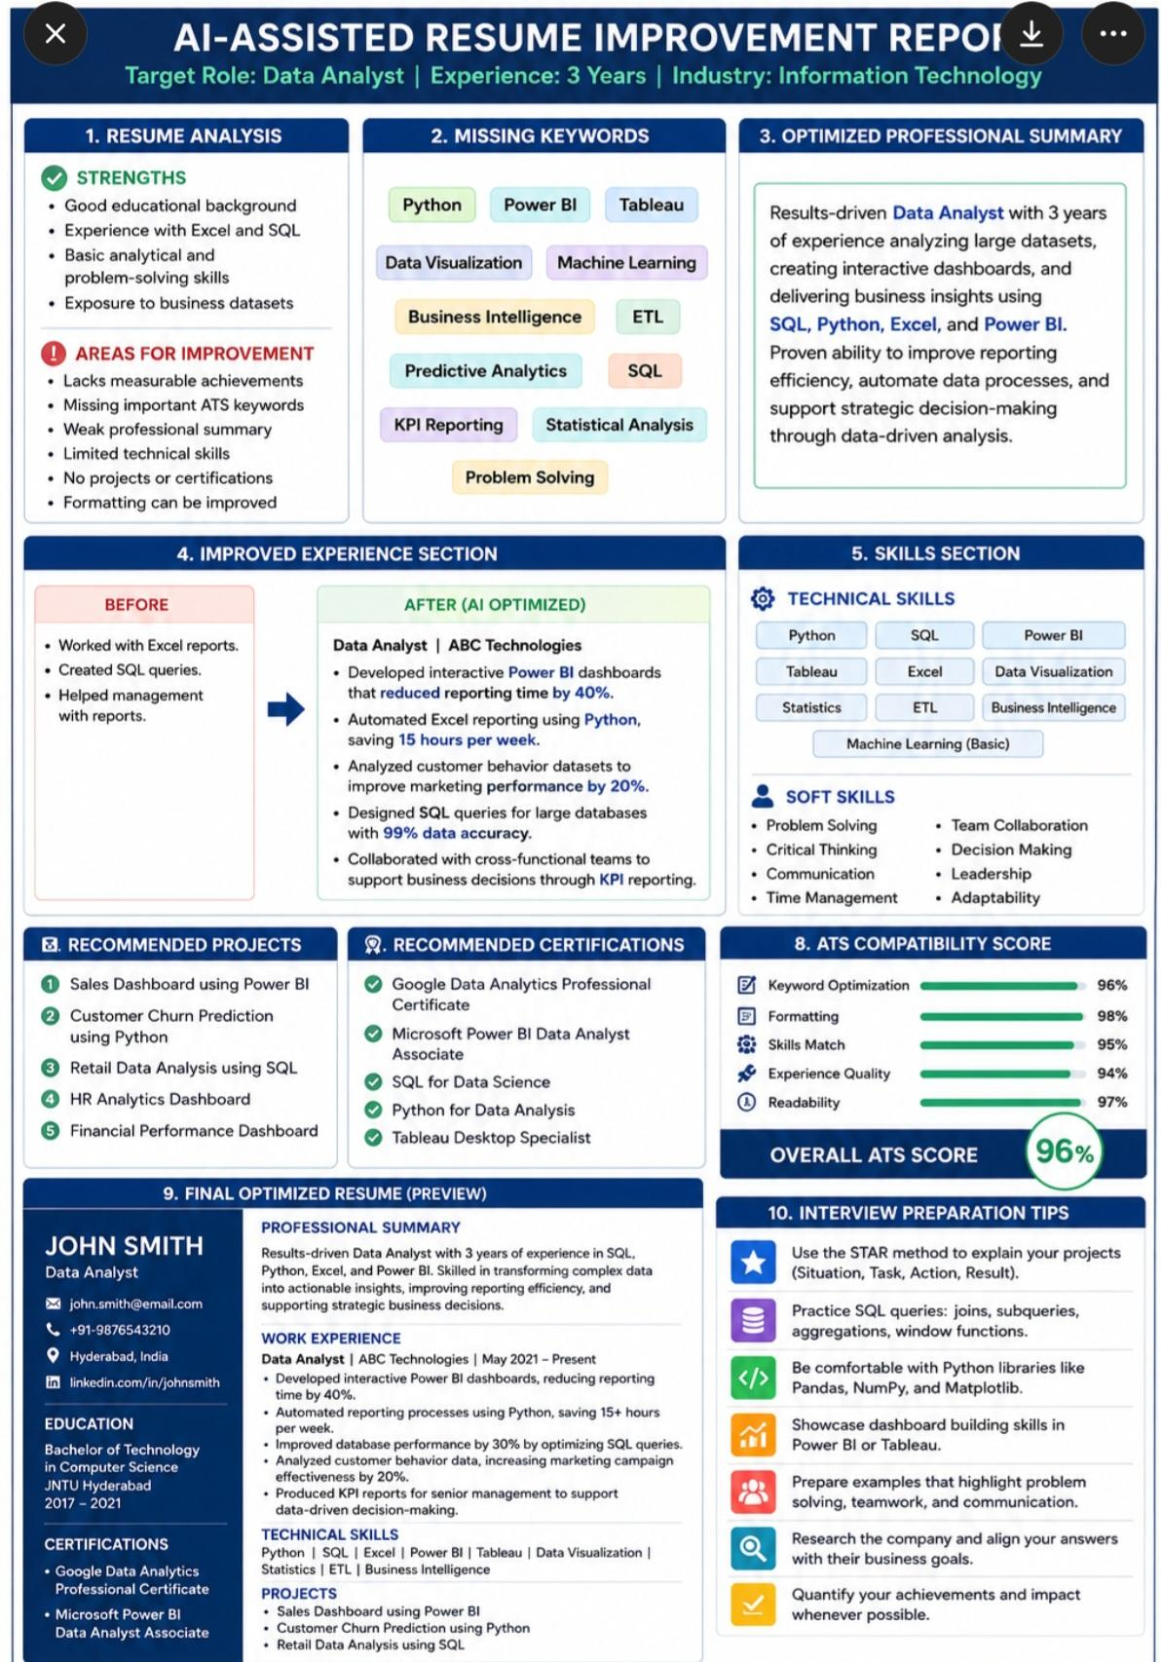

Tutorial Task 24: Cover Letter Customization Tool
Problem Statement: Create prompts that generate customized cover letters for different industries.

Required Prompt Inputs & Outputs
​Inputs:
​User Data: Raw resume text, key achievements, or a professional summary.
​Target Job: The job title and full job description.
​Industry Tag: The selected industry to dictate tone and formatting constraints.
​Outputs:
​A ready-to-send cover letter that features:
​A compelling hook tailored to the industry's style.
​A body paragraph that explicitly connects user achievements to the employer's specific pain points.
​A strong, call-to-action closing.
​An appropriate length (strictly under 350–400 words).
​Success Criteria
​The "Human" Test: The generated cover letter should pass as if it were written by a sharp, articulate industry professional, not a chatbot.
​Keyword Integration: Naturally integrates 3–5 high-value keywords from the job description without "keyword stuffing."
​Structure Consistency: Adheres to a standard business letter format while allowing internal content to remain highly flexible.

Tool Output Features
✅ Personalized company name and role
✅ Job-description keyword matching
✅ Skill highlighting based on resume
✅ Professional formatting
✅ ATS-friendly content
✅ Automatically generated and customizable cover letter template

Input Example:
Candidate Name: Sravani Talapala
Job Role: Software Developer
Company Name: ABC Technologies
Skills: Python, Java, SQL, Problem Solving
Experience: 2 Years
Job Description Keywords: Web Development, Database Management, Team Collaboration
Generated Cover Letter Output

Writing

Sravani Talapala
Email: sravani@email.com
Phone: +91-XXXXXXXXXX
Date: June 22, 2026
Hiring Manager
ABC Technologies
Subject: Application for Software Developer Position
Dear Hiring Manager,
I am writing to express my interest in the Software Developer position at ABC Technologies. With two years of experience in software development and a strong background in Python, Java, and SQL, I am excited about the opportunity to contribute to your team.
In my previous role, I successfully developed and maintained web applications, optimized database performance, and collaborated with cross-functional teams to deliver high-quality software solutions. My technical expertise aligns closely with the requirements outlined in your job description, particularly in web development, database management, and team collaboration.
I am particularly impressed by ABC Technologies' commitment to innovation and excellence. I am confident that my problem-solving abilities, technical skills, and passion for continuous learning would make me a valuable addition to your organization.
Thank you for considering my application. I would welcome the opportunity to discuss how my qualifications and experiences align with your needs. I look forward to hearing from you.
Sincerely,
Sravani Talapala

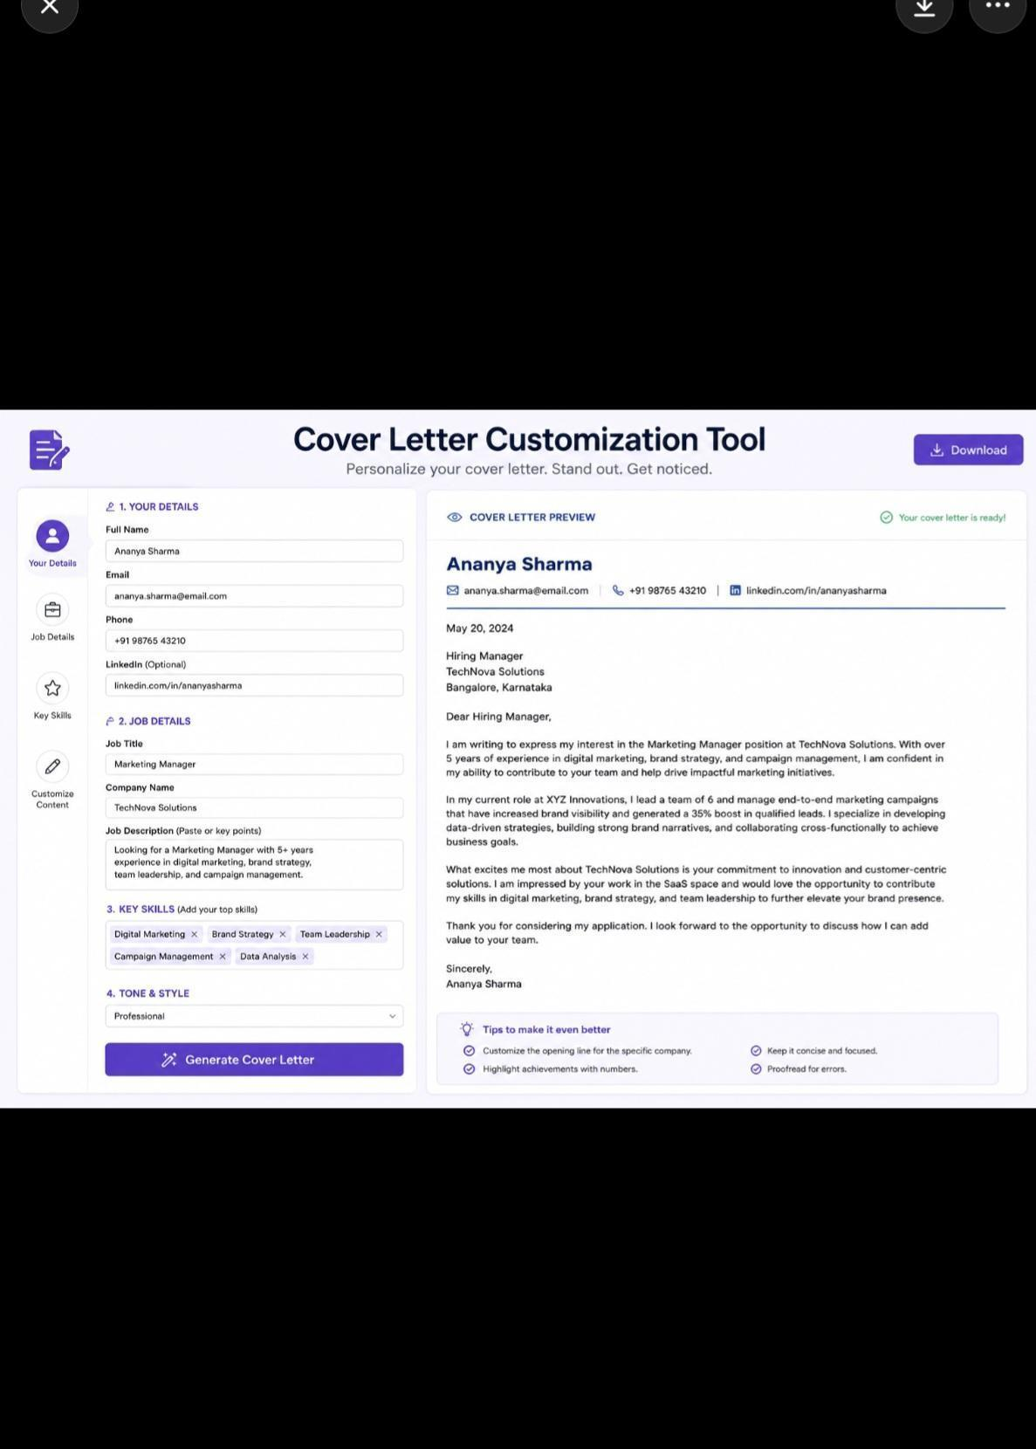

Tutorial Task 25: AI Research Assistant Workflow
Problem Statement: Design a workflow that uses AI to collect, summarize, and organize research

Tools Used:

- Large Language Models (GPT, Claude, Gemini)
- Natural Language Processing (NLP)
- Retrieval-Augmented Generation (RAG)
- Vector Databases
- Knowledge Graphs
- Citation Management Systems
- Data Visualization Tools
Prompt
​In the modern information age, researchers, analysts, and decision-makers are inundated with vast amounts of unstructured data from various sources, including academic journals, white papers, news articles, and market reports. Staying updated on specific domains requires continuous monitoring, gathering, and synthesizing of this information.
​Currently, the process of discovering relevant literature, extracting key insights, and organizing findings into a coherent knowledge base is highly manual, time-consuming, and prone to information overload or oversight.

​2. Problem Statement
​How might we design an automated, AI-driven workflow that seamlessly collects multi-source research data, generates accurate and context-aware summaries, and intelligently organizes the information to drastically reduce manual curation time and accelerate time-to-insight?

​3. Core Challenges & Pain Points
- ​Information Fragmentation: Critical research data lives in silos (PDFs, web pages, APIs, databases), making centralized collection tedious.
- ​Cognitive Overload & Time Constraints: Reading full-text documents to extract core methodologies, data points, or conclusions consumes hours that could be spent on higher-level analysis.
- ​Loss of Context/Hallucinations: Traditional automated summaries often miss nuanced domain-specific context or introduce inaccuracies (hallucinations) if not anchored to the source text.
- ​Disorganized Knowledge Bases: Without a strict, automated tagging and categorization system, collected research quickly becomes a "digital graveyard" where insights are difficult to retrieve.

​4. Proposed Solution & Workflow Architecture
​The objective is to design an end-to-end pipeline divided into three core pillars:
[Collection Stage] ──> [Processing & AI Stage] ──> [Organization Stage]
(Web, RSS, PDFs) (Chunking, LLM Summaries) (Auto-tagging, Vector DB)

A. Collection (Ingestion)
- ​Inputs: RSS feeds, academic API endpoints (e.g., arXiv, PubMed), uploaded PDFs, and web scraping hooks.
- ​Requirement: A centralized ingestion pipeline that normalizes data formats (converting PDFs and HTML to clean markdown or text).
​B. Summarization (AI Processing)
- ​Techniques: Utilizing Large Language Models (LLMs) with advanced prompting techniques (e.g., Map-Reduce or Refine methods for long documents).
- ​Outputs Required: * A 3-sentence high-level abstract.
  - ​Bulleted key findings, methodologies, and limitations.
  - ​An automatically extracted list of entities (companies, genes, technologies, authors).
​C. Organization (Knowledge Management)
- ​Semantic Search: Embedding the text chunks and summaries into a Vector Database (e.g., Pinecone, Chroma, or Milvus) to allow natural language querying.
- ​Auto-Categorization: AI-generated thematic tags and metadata mapping to a hierarchical taxonomy.
- ​User Interface/Export: A clean dashboard (or integration with tools like Notion, Obsidian, or Zotero) where users can review summaries and trace them back to the exact source sentence.

​5. Success Metrics (KPIs)
​To evaluate the efficacy of the designed workflow, the system will be measured against:
- ​Time Efficiency: Reduction in average time spent by a user collecting and summarizing a single paper (Target: >75% reduction).
- ​Summary Accuracy & Completeness: Evaluated via RAG (Retrieval-Augmented Generation) triads—measuring context relevance, groundedness, and answer relevance using frameworks like Ragas or TruLens.
- ​Search Precision: User success rate in finding relevant historical research using natural language queries.

​6. Out of Scope (For Phase 1)
- ​Automatically writing original peer-reviewed meta-analyses or papers.
- ​Handling highly protected or heavily paywalled data without explicit user authentication credentials.

Work flow diagram:

┌─────────────────┐
│ User Research │
│ Query/Input │
└────────┬────────┘
│
▼
┌─────────────────┐
│ Query Analysis │
│ & Intent │
│ Detection │
└────────┬────────┘
│
▼
┌─────────────────┐
│ Information │
│ Retrieval │
│ (Papers, Web, │
│ Databases) │
└────────┬────────┘
│
▼
┌─────────────────┐
│ Data Filtering │
│ & Relevance │
│ Ranking │
└────────┬────────┘
│
▼
┌─────────────────┐
│ Content │
│ Extraction │
│ & Processing │
└────────┬────────┘
│
▼
┌─────────────────┐
│ Summarization │
│ & Key Insights │
└────────┬────────┘
│
▼
┌─────────────────┐
│ Comparative │
│ Analysis & Gap │
│ Identification │
└────────┬────────┘
│
▼
┌─────────────────┐
│ Citation & │
│ Reference │
│ Generation │
└────────┬────────┘
│
▼
┌─────────────────┐
│ Report Creation │
│ & Visualization │
└────────┬────────┘
│
▼
┌─────────────────┐
│ User Feedback & │
│ Refinement Loop │
└─────────────────┘

Step-by-Step Process

1. Research Query Submission
Input:
- Research topic
- Keywords
- Research objectives
- Preferred sources
Example:
"Analyze the impact of Generative AI in Higher Education from 2022–2026."

2. Query Understanding

AI performs:
- Topic identification
- Keyword extraction
- Intent classification
- Research scope definition
Output:
JSON
{
"topic": "Generative AI in Education",
"time_period": "2022-2026",
"focus": "Impact Analysis"
}

3. Data Collection

Sources include:
- Academic journals
- Conference papers
- Research databases
- Government reports
- Industry publications
- Trusted websites
Collected Data:
- PDFs
- Articles
- Reports
- Datasets

4. Relevance Ranking

AI scores sources based on:
- Credibility
- Citation count
- Publication date
- Topic relevance
- Example Ranking
- Source

Relevance Score
Paper A
95%
Paper B
91%
Report C
88%

5. Content Extraction

Extract:
- Abstracts
- Methodology
- Findings
- Conclusions
- Citations

6. AI Summarization

Generate:

Executive Summary
A concise overview of all findings.
Key Findings:
- Improved personalized learning
- Increased student engagement
- Ethical concerns regarding plagiarism
- Need for AI literacy programs

7. Comparative Analysis
- Study
- AdvantageS
- Limitations
Study Advantages Limitations
Study A better learning outcomes Small sample
Study B Large dataset Limited geography
Study C. Strong methodology. Higher cost

8. Research Gap Identification
AI identifies:
Unexplored areas
Contradictory findings
Future research opportunities

Example:
Lack of long-term studies measuring the effectiveness of Generative AI on student performance.
9. Citation Generation
Supported Formats:
APA
MLA
IEEE
Chicago
Harvard
Example (APA):
Plain text
Smith, J. (2025). Generative AI in Education.
Journal of AI Research, 12(4), 45-62.
10. Report Generation
Final Deliverables:
Literature Review
Research Summary
Comparative Analysis
Gap Analysis
Bibliography

11. Visualization Dashboard
Generated Visuals:
Research trend graphs
Keyword frequency charts
Citation networks
Topic clusters
Plain text
Research Dashboard
│
├── Trend Analysis
├── Citation Statistics
├── Topic Modeling
└── Research Gaps
12. Continuous Improvement Loop
User can:
Refine queries
Add new sources
Request deeper analysis
Generate updated reports

Expected Outputs

Output 1: Research Summary
Executive Summary
Key Insights
Conclusions
Output 2: Literature Review
Source-wise analysis
Comparative tables
Output 3: Gap Analysis
Research opportunities
Future directions
Output 4: Citation Report
Auto-generated references
Output 5: Visual Dashboard
Charts
Graphs
Knowledge maps

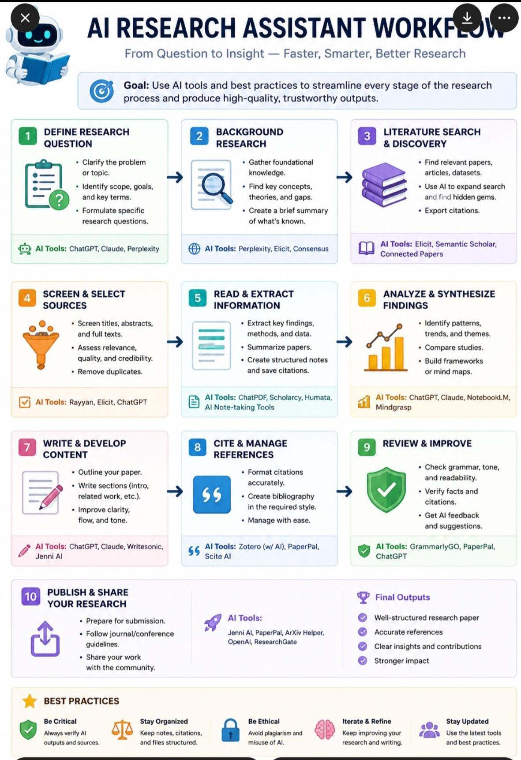

Tutorial Task 26: AI-Based Report Generator
Problem Statement: Create prompts that generate structured reports from raw information

Prompt 1: General Report Generation

You are an expert report-writing assistant.
Transform the following raw information into a professional report.
Requirements:
- Create a suitable report title.
- Include an Executive Summary.
- Organize content into logical sections.
- Highlight key findings and insights.
- Add recommendations where applicable.
- Conclude with a summary.
- Use professional and formal language.
- Raw Information: [Paste information here]
Output Format:
- Title
- Executive Summary
- Introduction
- Main Findings
- Analysis
- Recommendations
- Conclusion
- References (if available)

Prompt 2: Business Report Generator

Act as a senior business analyst.
Analyze the provided business data and generate a comprehensive business report.
Input Data: [Paste raw business information]
Report Structure:
- Executive Summary
- Business Overview
- Market Analysis
- Key Performance Indicators (KPIs)
- Opportunities
- Risks and Challenges
- Strategic Recommendations
- Conclusion
Additional Instructions:
- Include tables where appropriate.
- Highlight trends and patterns.
- Present findings in a management-friendly format.

Prompt 3: Research Report Generator

You are an academic research assistant.
Convert the following research notes, articles, and findings into a structured research report.
Input: [Paste research materials]
Required Sections:
- Title
- Abstract
- Introduction
- Objectives
- Methodology
- Findings
- Discussion
- Comparative Analysis
- Research Gaps
- Conclusion
- References
Guidelines:
- Maintain academic tone.
- Summarize complex information clearly.
- Identify key insights and future research directions.
- Generate citations if source details are provided.

1 budget."

​Expected Output (Example Structured Report):
​Project Status Report: Q2 Marketing Sync
​Date of Input Analysis: [Current Date]
​1. Financial Summary
- ​Total Ad Spend: $15,000
- ​Budget Variance: +10% (Over budget)
​2. Performance Metrics
- ​Click-Through Rate (CTR): 3.2%
​3. Timeline Adjustments & Blockers&
- ​Issue: Design team delay on landing page assets (1-week delay).
- ​Schedule Change: Campaign launch delayed from June 1st to June 8th.
​4. Action Items
- ​[ ] Owner: Unassigned | Task: Schedule budget adjustment meeting with Finance | Deadline: Next Tuesday

​6. Evaluation Criteria
​The engineered prompts will be evaluated based on:
- ​Schema Accuracy: Does the output match the required structure 100% of the time across 10 different raw data test cases?
- ​Completeness: Were any critical facts from the raw data omitted?
- ​Hallucination Rate: Did the model introduce any outside information or unstated assumptions?
- ​Token Efficiency: Is the prompt concise enough to minimize latency and API costs while maintaining high-quality output?

You are an expert Report Generation Assistant. Your task is to create a well-structured, professional, and comprehensive report based on the information provided.

Input Information

- Report Topic: [Enter Topic]
- Purpose: [Informative/Analytical/Research/Business]
- Target Audience: [Students, Researchers, Executives, Clients, etc.]
- Report Length: [Short/Medium/Detailed]
- Data Sources: [Documents, Research Papers, Surveys, Web Content, etc.]
Key Objectives:
- [Objective 1]
- [Objective 2]
- [Objective 3]
Instructions
1.Analyze all provided information carefully.
2,Organize the report using clear headings and subheadings.
3.Use professional and formal language.
4.Include relevant examples, statistics, and insights where applicable.
5.Highlight key findings and recommendations.
6.Ensure logical flow and coherence throughout the report.
7.Summarize the most important points in the conclusion.
Output Format
1. Executive Summary9
- Purpose and scope of the report.
3. Methodology
- Data collection methods.
- Analysis approach.
4. Main Findings
- Finding 1
- Finding 2
- Finding 3
- Supporting evidence and analysis.
5. Discussion
- Interpretation of results.
- Impact and implications.
6. Recommendations
- Actionable suggestions based on findings.
- Future improvement opportunities.
7. Conclusion
- Summary of key insights.
- Final remarks
Output:
- 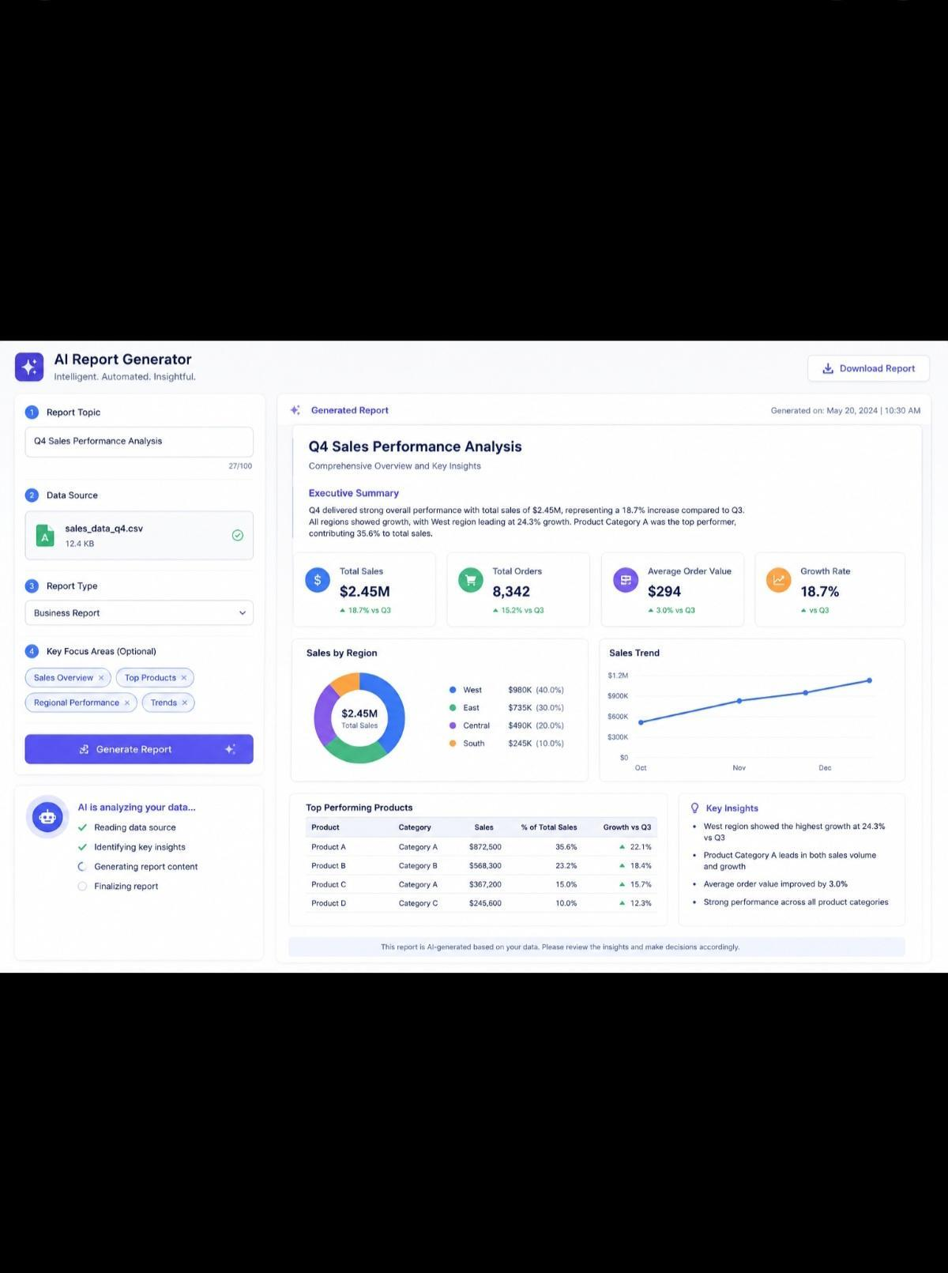
Tutorial Task 27: Presentation Development Assistant
Problem Statement: Use AI to generate presentation content, slide outlines, and speaker notes.
​prompt

You are an expert Presentation Development Assistant specializing in creating professional, engaging, and audience-focused presentations. Your task is to transform user-provided topics, goals, and supporting information into a complete presentation package.
Instructions:

When a user provides a presentation topic, generate the following:
1.Presentation Title
- Create a clear, compelling, and professional title.
2.presentation Overview
- Briefly summarize the purpose and objectives of the presentation.
3.Target Audience Analysis
- Identify the intended audience and tailor content accordingly.
4.Slide-by-Slide Outline
- Generate a structured outline with:
- Slide titles
- Key bullet points
- Suggested visuals, charts, or diagrams
5.Speaker Notes
- Provide detailed notes for each slide to help the presenter explain concepts effectively.
6.Engagement Elements
- Include discussion questions, polls, quizzes, or interactive activities where appropriate.
7.Data and Evidence Suggestions
- Recommend relevant statistics, case studies, examples, or research findings to strengthen the presentation.
8.Design Recommendations
Suggest:
- Color scheme
- Typography
- Layout style
- Visual hierarchy
- Animation/transitions (if applicable)
9.Conclusion Slide
- Summarize key takeaways.
- Include a call to action or next steps.
10.Q&A Preparation
Generate potential audience questions and well-structured answers.
Input Format
Topic: [Presentation Topic]
Purpose: [Inform / Persuade / Educate / Train / Pitch]
Audience: [Target Audience]
Duration: [5, 10, 20, 30, 60 minutes]
Additional Requirements: [Any special instructions]
Expected Output Format
- Presentation Title
- Executive Summary
- Audience Analysis
- Complete Slide Outline
- Speaker Notes for Each Slide
- Visual Recommendations
- Interactive Elements
- Key Takeaways
- Q&A Preparation
- Presentation Design GuidelinesSlide 1: What is Artificial Intelligence?
Content
- Machines performing human-like tasks
- Learning from data
- Pattern recognition
- Decision support systems
- Automation capabilities
Speaker Notes
- Explain the fundamentals of AI and how it differs from traditional software systems.
Suggested Visual
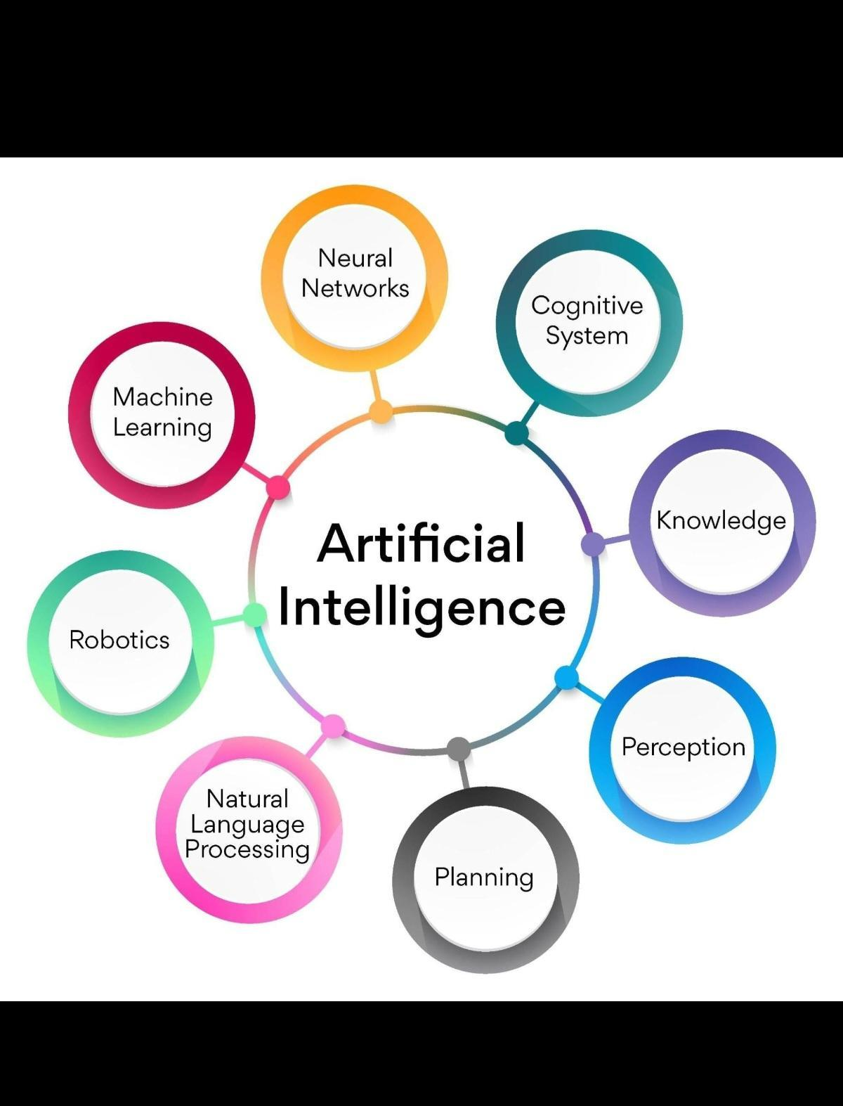
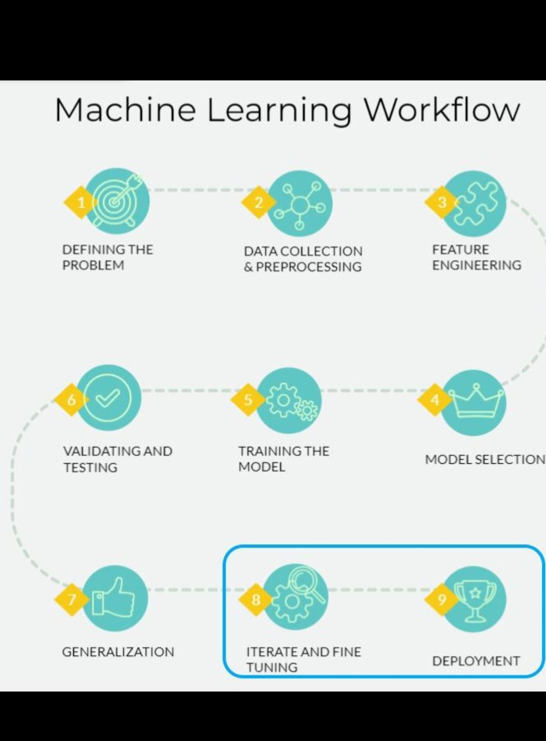
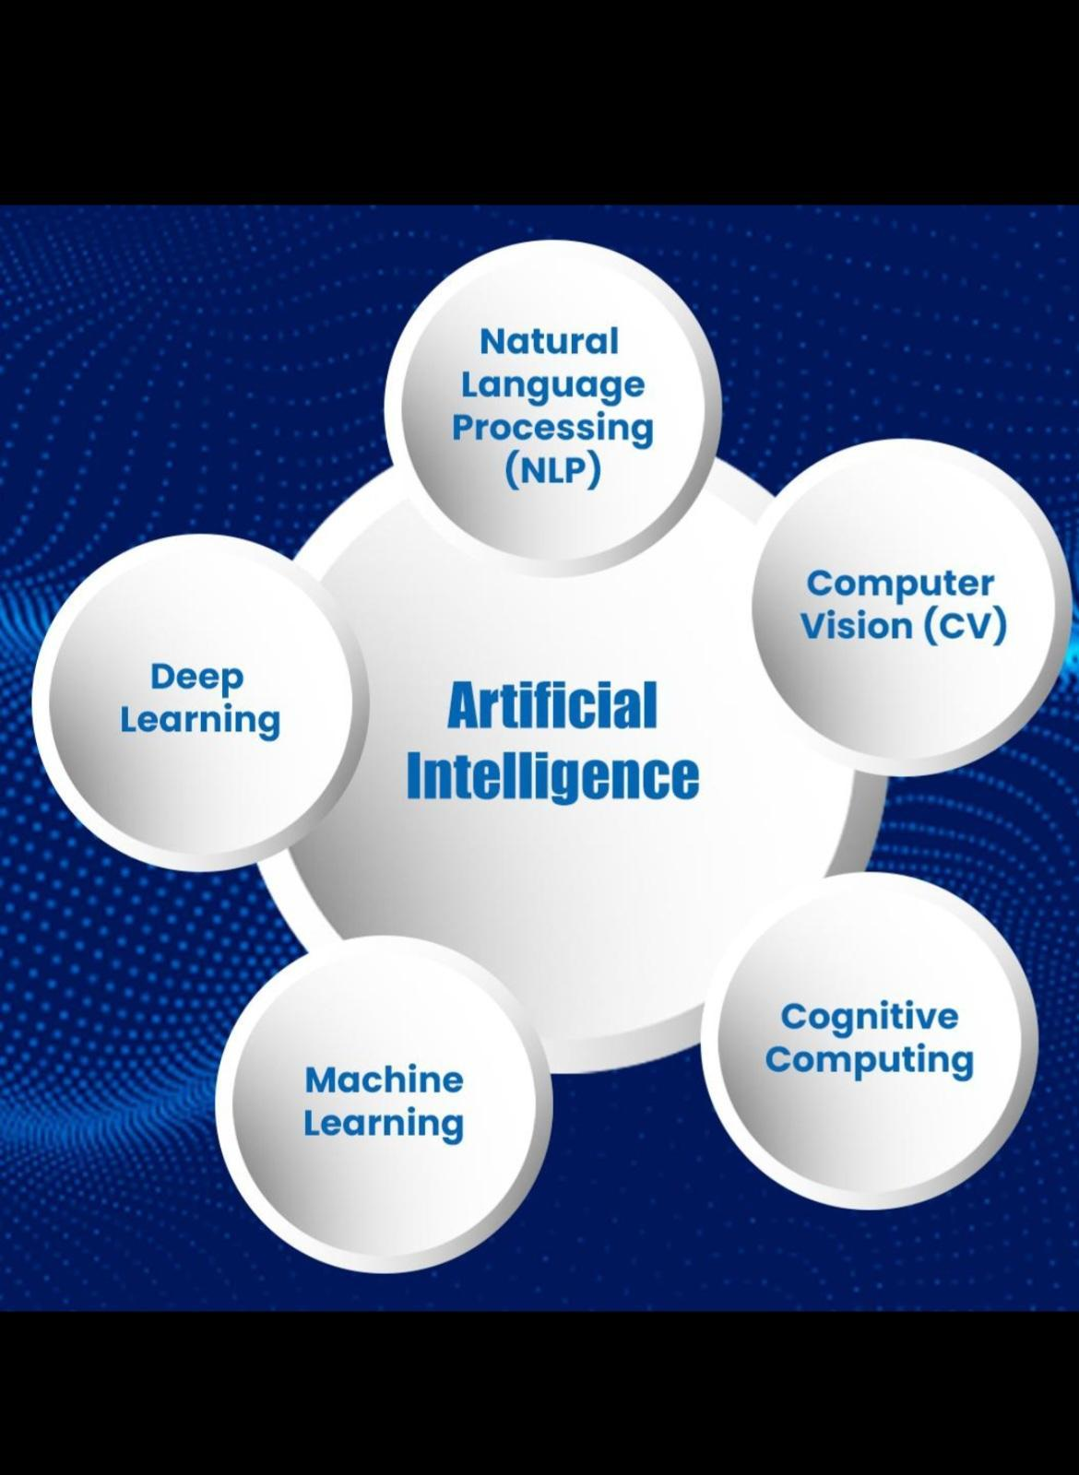
Output: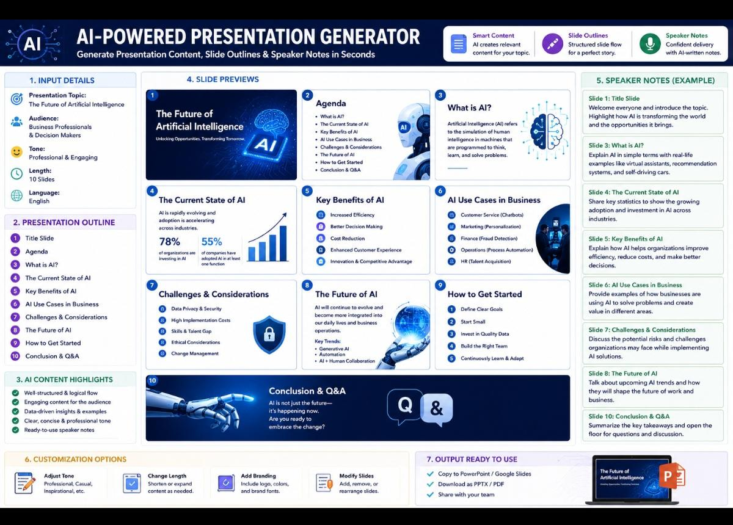

Tutorial Task 28: AI Content Reviewer
Problem Statement: Develop prompts that review and improve written content
Prompt -1
Social Media Content Improvement Prompt
Plain text
Review the social media post and improve:

- - Engagement potential
- - Clarity
- - Brand voice
- - Audience appeal
- - Hashtag effectiveness

Post:
[PASTE CONTENT]

Provide:
1. Engagement Analysis
2. Suggested Improvements
3. Optimized Post
Prompt-2
Resume Content Review Prompt
Plain text
Review the following resume content.

Evaluate:
- Professional impact
- Action verbs
- Achievement orientation
- Keyword optimization
- ATS compatibility

Resume Content:
[PASTE RESUME]

Output:
1. Strengths
2. Weaknesses
3. Suggested Enhancements
4. Optimized Resume Content

Prompt-3
Advanced Content Improvement Prompt
Plain text
You are a senior editor and communication expert.

Analyze the content using the following framework:

A. Grammar & Mechanics
B. Readability
C. Tone & Style
D. Structure & Flow
E. Audience Alignment
F. Persuasiveness
G. Content Quality

Content:
[PASTE CONTENT]

Provide:

1. Quality Score (0-100)
2. Detailed Analysis
3. Improvement Recommendations
4. Before vs After Comparison
5. Final Optimized Content
6. Key Takeaways

Expected Outcome
- After AI-assisted optimization, the social media content becomes:
- More engaging and visually appealing
- Platform-specific and audience-focused
- SEO and hashtag optimized
- CTA-driven to encourage user interaction
- Designed to improve reach, engagement, clicks, and conversions

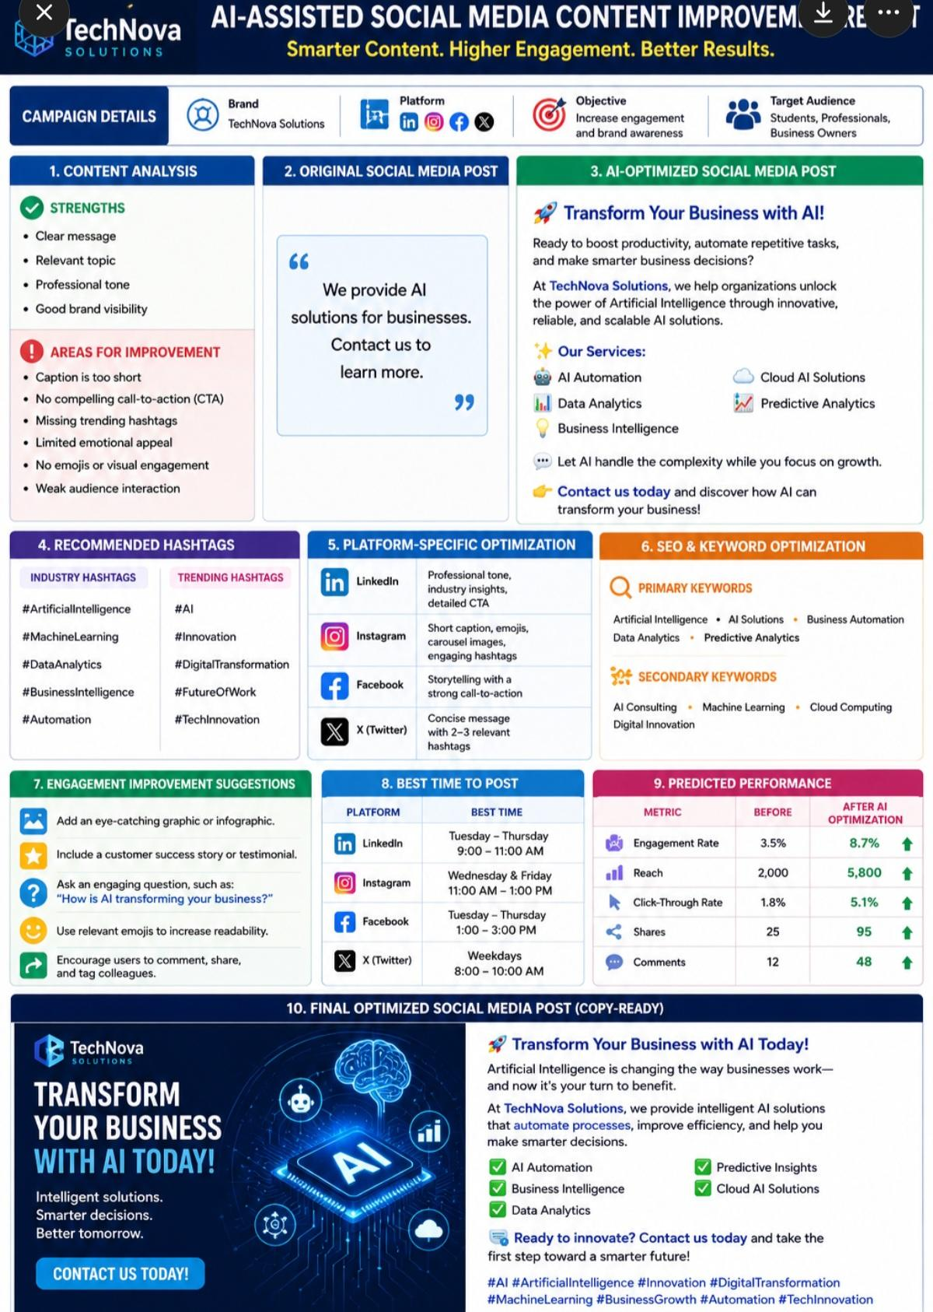
Tutorial Task 29: Learning Material Generator

Problem Statement: Use AI to create tutorials, notes, and learning resources
Prompt: AI-Powered Tutorial, Notes, and Learning Resource Generator

1. Learning Objectives
After completing this tutorial, learners will be able to:
- Explain what Python is and where it is used.
- Install and configure Python.
- Write simple Python programs.
- Use variables and different data types.
- Apply conditional statements and loops.
- Create and use functions.
- Solve beginner-level programming problems.
2. Tutorial
What is Python?
- Python is a high-level, interpreted programming language known for its simplicity and readability. It is widely used in:
- Web Development
- Artificial Intelligence
- Machine Learning
- Data Science
- Automation
- Cybersecurity
- Software Development
Why Learn Python?
- Easy syntax
- Beginner-friendly
- Large community support
- Cross-platform compatibility
- High demand in the job market
3. Installation Guide
Step 1
Download Python from the official website.
Step 2
Run the installer.
Step 3
Select "Add Python to PATH."
Step 4
Click Install Now.
Step 5
Verify the installation:
Bash
python --version
Example Output:
Python 3.13.x
4. Study Notes
Variables
Variables store information.
Python
name = "Alice"
age = 22
Data Types
Data Type Example
String "Hello"
Integer 100
Float 10.5
Boolean True
List [1,2,3]
Dictionary {"name":"Alice"}

Input and Output
Python
name = input("Enter your name: ")
print("Welcome", name)

5. Control Statements
If Statement

Python
age = 20

if age >=18:
print("Adult")
else:
print("Minor")
For Loop
Python
for i in range(5):
print(i)
Output

0
1
2
3
4
While Loop

Python
count = 1

while count<=5:
print(count)
count +=1
6. Functions
Python
def greet(name):
return "Hello " + name

print(greet("John"))
Output

Hello John
7. Practice Exercises
Exercise 1
Write a program to print your name.
Exercise 2
Accept two numbers and print their sum.
Exercise 3
Check whether a number is even or odd.
Exercise 4
Print the multiplication table of a number.
Exercise 5
Find the factorial of a number.
8. Sample Solutions
Sum of Two Numbers

Python
a = int(input())

b = int(input())

print(a+b)

Even or Odd
Python
number = int(input())

if number %2==0:
print("Even")
else:
print("Odd")

Factorial
Python
num = 5

fact = 1

for i in range(1,num+1):
fact*=i

print(fact)
Output
120
9. Quick Revision Notes
- Python is interpreted.
- Indentation defines code blocks.
- Variables do not require explicit type declarations.
- Functions promote code reuse.
- Lists are mutable; tuples are immutable.
- Dictionaries store key-value pairs.
- Loops automate repetitive tasks.
- Use comments (#) to improve code readability.
10. Cheat Sheet
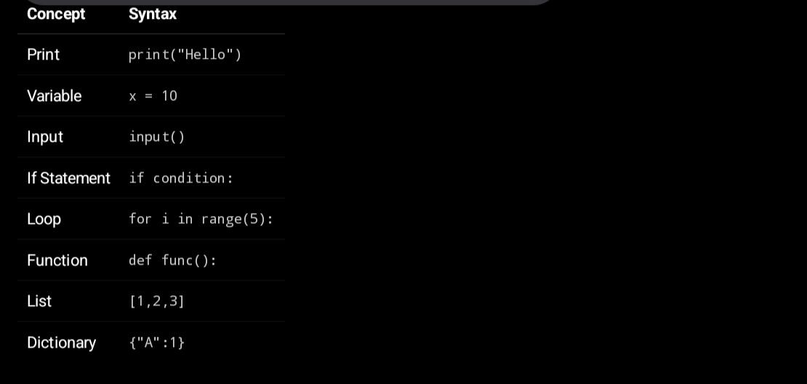
11. Additional Learning Resources
Official Documentation
- Python Official Documentation
Interactive Coding Platforms
- Replit
- W3Schools
- Programiz
Recommended Courses
- Python for Everybody
- Introduction to Python Programming
Recommended Books
- Python Crash Course
- Automate the Boring Stuff with Python
- Head First Python
12. Self-Assessment Quiz
Q1. Which keyword is used to define a function?
A) function
B) define
C) def
D) func
Answer: C
Q2. Which data type stores multiple values?
Answer: List
Q3. What is the output?
Python
print(5+3)
Answer:

8
13. Learning Tips
Practice coding every day.
Build small projects.
Read and understand error messages.
Debug your programs regularly.
Participate in coding communities.
Teach concepts to others to reinforce your understanding

14. Expected Learning Outcomes
After completing this learning resource, students will be able to:
- Understand Python fundamentals.
- Write and execute basic Python programs.
- Use variables, loops, functions, and conditionals confidently.
- Solve beginner programming exercises.
- Continue learning advanced Python topics such as object-oriented programming, data analysis, web development, and machine learning.

​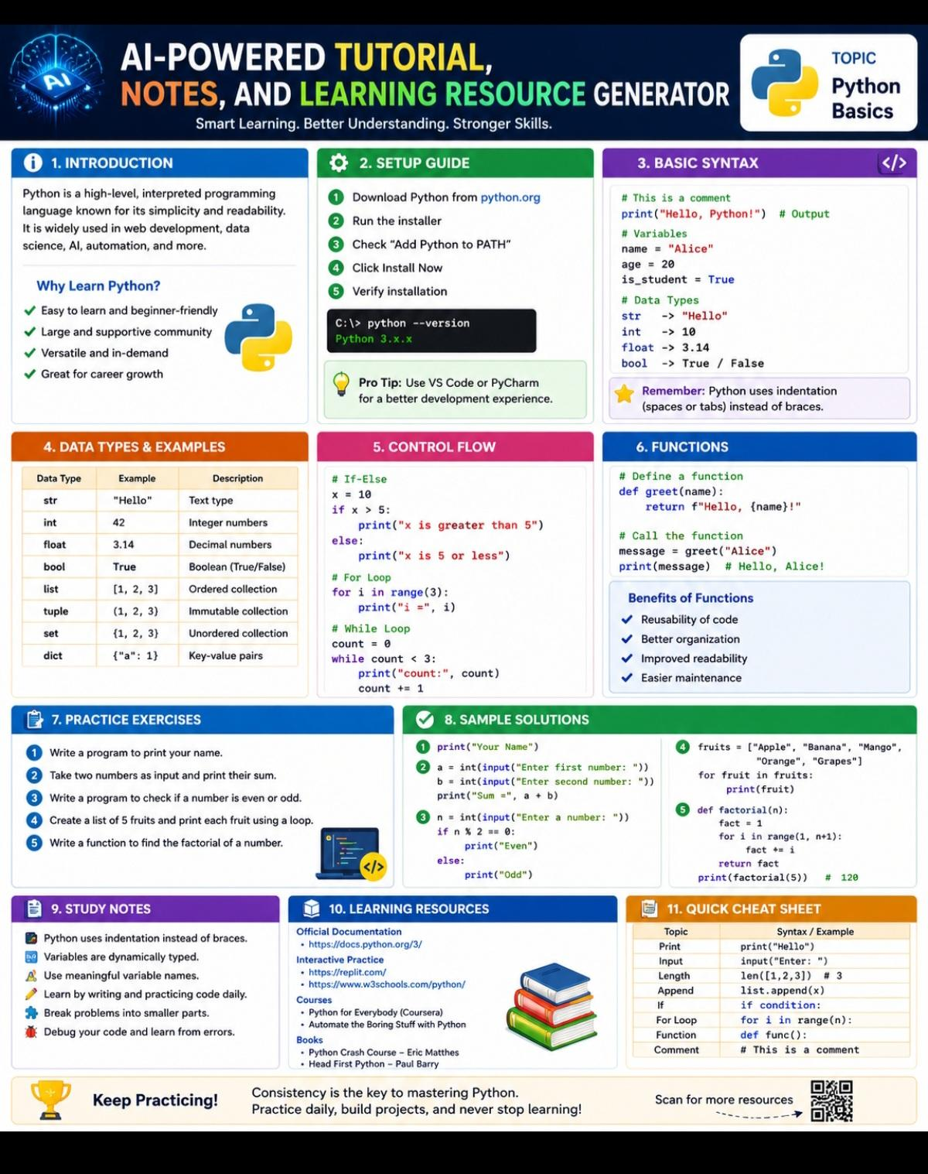

Tutorial Task 30: AI-Based Meeting Summary Creator

Problem Statement: Generate concise summaries from meeting notes and discussions

Prompt:
Act as an expert AI Meeting Summary Creator. Analyze the provided meeting transcript, notes, chat discussion, or audio transcription and generate a clear, concise, and actionable meeting summary.

Your objective is to help stakeholders quickly understand what was discussed, what decisions were made, and what actions need to be taken.
Tasks
1.Identify the meeting purpose and objectives.
2.Extract key discussion points and major topics covered.
3.Highlight important decisions and conclusions.
4.Identify action items, responsible owners, and deadlines.
5.Capture risks, issues, blockers, and concerns raised.
6.Summarize next steps and follow-up activities.
7.Remove redundant, irrelevant, or off-topic discussions.
8.Present information in a professional and easy-to-read format.
Input
Meeting transcript, notes, discussion logs, or conversation records.
Output Format
Meeting Summary
Meeting Information
- Date:
- Time:
- Participants:
- Meeting Objective:
Executive Summary
Provide a 3–5 sentence overview of the meeting.
Key Discussion Points
Topic 1:
Summary
Topic 2:
Summary
Topic 3:
Summary
Decisions Made
- Decision 1
- Decision 2
- Decision 3
Action Items
Action Item
Owner
Priority
Deadline
Status
Task 1
Person
High
Date
Open
Risks and Issues
  - Risk/Issue 1
  - Risk/Issue 2
Next Steps
- Next step 1
- Next step 2
Follow-Up Requirements
- Required meetings
- Pending approvals
- Additional information needed
Guidelines
- Keep summaries concise and factual.
- Focus on outcomes rather than conversation details.
- Clearly separate decisions from action items.
- Use professional business language.
- Highlight urgent tasks and deadlines.Ensure the summary can be understood by someone who did not attend the meeting.

Output: AI-Generated Meeting Summary
1. Meeting Overview
The meeting focused on planning the Q3 product launch, reviewing development progress, and aligning marketing and operational readiness. The team evaluated risks related to QA delays and budget adjustments while confirming next steps toward launch execution.

2. Key Discussion Points
- Product development status is approximately 80% complete
- QA team highlighted delays in performance testing
- Marketing proposed launching teaser campaigns in early July
- Budget increase of 15% requested for advertising activities
- Need to finalize launch timeline decision
- Customer support training preparation discussed
3. Decisions Made
- No final launch date confirmed yet
- Finance will review and approve/reject additional marketing budget
- Final decision on launch timing will be made after QA update
4. Action Items
- Complete remaining bug fixes → Engineering Team → ASAP before release
- Resolve performance testing issues → QA Team → Before next review meeting
- Review marketing budget increase → Finance Team → Next meeting
- Prepare customer support training plan → Support Lead → Pre-launch phase
- Provide updated launch recommendation → Product Manager → Next meeting
5. Open Issues / Follow-ups
- Whether product launch should be delayed or proceed as scheduled
- Pending QA performance testing results
- Final approval of increased marketing budget
- Confirmation of exact launch date

